**Introduction**

This week we test for the presence of a potential moderator variable exists between, i.e if there is an association between 2 constructs for different subgroups within and the sample. Here we test if NATO and or EU membership for European countries has a moderating effect on the level of linear correlation between Incomer per person and polity score (how politically free a country is).

**Experimental**

For the different NATO and EU membership status we measure the correlation between income per person and polityscore for the different groups. We find the correlation for the four different groups to be non-statistically significant (though the correlation value does vary). This is shown visually with the scatter plots below. Therefore we cannot find any evidence for Nato EU membership for European countries being a moderating variable.

association between income per person and polityscore for Not_In_Nato_Not_In_EU countries

(0.28507317588491865, 0.39549208562565802)

association between income per person and polityscore for Not_In_Nato_In_EU countries

(0.70002199963350153, 0.50634701043213792)

association between income per person and polityscore for Not_In_Nato_In_EU countries

(nan, 1.0)

association between income per person and polityscore for Nato_And_EU countries

(0.23850250146232868, 0.32545088846906162)

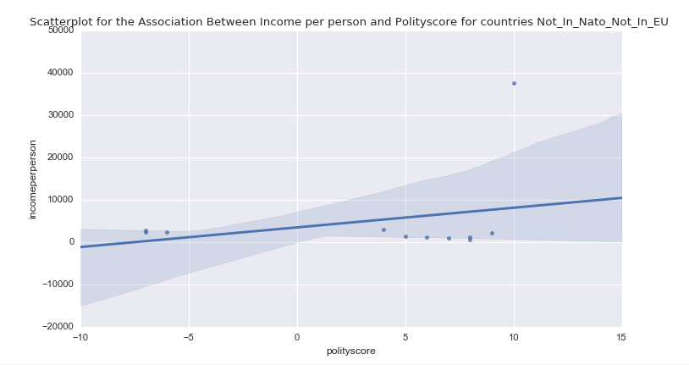

Figure. Scatterplot for the Association Between Income per person and Polity score for countries Not_In_Nato_Not_In_EU.

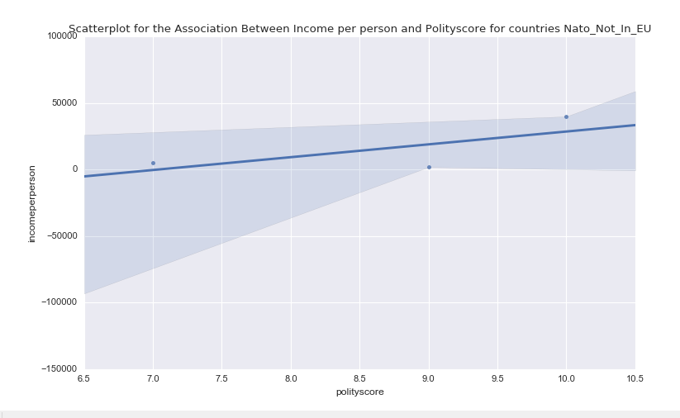

Figure. Scatterplot for the Association Between Income per person and Polity score for countries Nato_Not_In_EU.

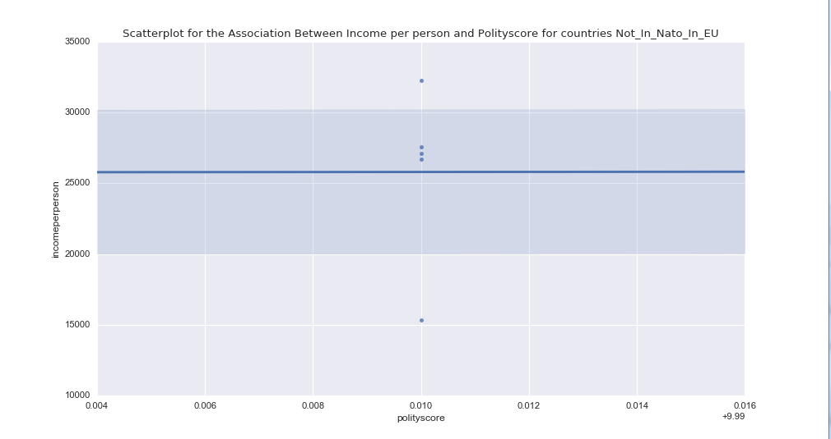

Figure. Scatterplot for the Association Between Income per person and Polity score for countries Not_In_Nato_In_EU.

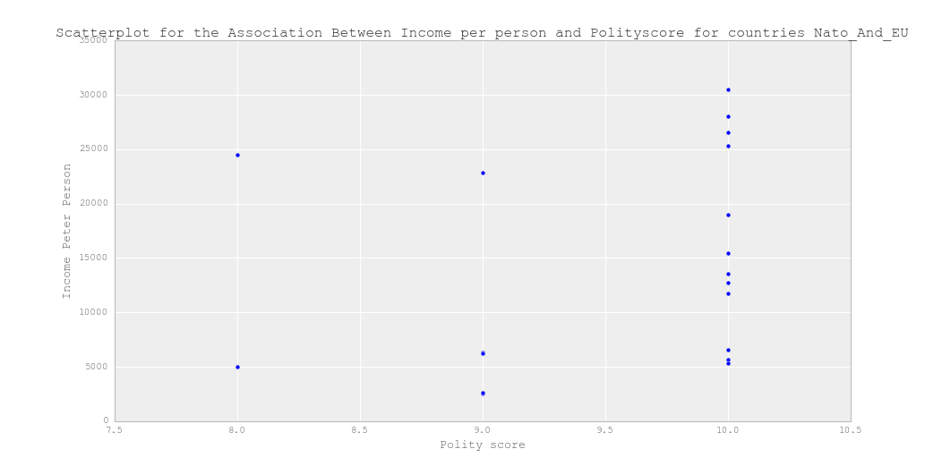

Figure. Scatterplot for the Association Between Income per person and Polity score for countries Nato_And_EU

**Conclusion**

No evidence could be found for NATO EU membership being a moderator variable with respect to the level of linear correlation between income per person and polity score.

**Code**

##looking for moderation

##segment for europena countries

pandas.unique(data['NATO_EU_MEMBERSHIP'])

##>> 'Not_In_Nato_Not_In_EU', 'Nato_Not_In_EU', 'Not_In_Nato_In_EU',

## 'Nato_And_EU'

subset_data_europe=dataanovatestdf=data[['incomeperperson','polityscore','NATO_EU_MEMBERSHIP']][data.European=='Europe']

subset_data_europe=subset_data_europe.dropna()

Not_In_Nato_Not_In_EU=subset_data_europe[subset_data_europe['NATO_EU_MEMBERSHIP']=='Not_In_Nato_Not_In_EU']

Nato_Not_In_EU=subset_data_europe[subset_data_europe['NATO_EU_MEMBERSHIP']=='Nato_Not_In_EU']

Not_In_Nato_In_EU=subset_data_europe[subset_data_europe['NATO_EU_MEMBERSHIP']=='Not_In_Nato_In_EU']

Nato_And_EU=subset_data_europe[subset_data_europe['NATO_EU_MEMBERSHIP']=='Nato_And_EU']

print ('association between income per person and polityscore for Not_In_Nato_Not_In_EU countries')

print (scipy.stats.pearsonr(Not_In_Nato_Not_In_EU['incomeperperson'], Not_In_Nato_Not_In_EU['polityscore']))

print ('association between income per person and polityscore for Not_In_Nato_In_EU countries')

print (scipy.stats.pearsonr(Nato_Not_In_EU['incomeperperson'], Nato_Not_In_EU['polityscore']))

print ('association between income per person and polityscore for Not_In_Nato_In_EU countries')

print (scipy.stats.pearsonr(Not_In_Nato_In_EU['incomeperperson'], Not_In_Nato_In_EU['polityscore']))

print ('association between income per person and polityscore for Nato_And_EU countries')

print (scipy.stats.pearsonr(Nato_And_EU['incomeperperson'], Nato_And_EU['polityscore']))

scat1 = seaborn.regplot(x="polityscore", y="incomeperperson", fit_reg=True, data=Not_In_Nato_Not_In_EU)

plt.xlabel('polityscore')

plt.ylabel('incomeperperson')

plt.title('Scatterplot for the Association Between Income per person and Polityscore for countries Not_In_Nato_Not_In_EU ')

scat2 = seaborn.regplot(x="polityscore", y="incomeperperson", fit_reg=True, data=Nato_Not_In_EU)

plt.xlabel('polityscore')

plt.ylabel('incomeperperson')

plt.title('Scatterplot for the Association Between Income per person and Polityscore for countries Nato_Not_In_EU')

scat3 = seaborn.regplot(x="polityscore", y="incomeperperson", fit_reg=True, data=Not_In_Nato_In_EU)

plt.xlabel('polityscore')

plt.ylabel('incomeperperson')

plt.title('Scatterplot for the Association Between Income per person and Polityscore for countries Not_In_Nato_In_EU')

scat4 = seaborn.regplot(x="polityscore", y="incomeperperson", fit_reg=False, data=Nato_And_EU)

plt.xlabel('polityscore')

plt.ylabel('incomeperperson')

plt.title('Scatterplot for the Association Between Income per person and Polityscore for countries Nato_And_EU')

matplotlib.pyplot.scatter(Nato_And_EU['polityscore'],Nato_And_EU['incomeperperson'])

## Chart title

matplotlib.pyplot.title('Scatterplot for the Association Between Income per person and Polityscore for countries Nato_And_EU')

# y label

matplotlib.pyplot.ylabel('Income Peter Person')

# x label

matplotlib.pyplot.xlabel('Polity score')

matplotlib.pyplot.show()

##try a facet plot

##g = seaborn.FacetGrid(subset_data_europe, col="NATO_EU_MEMBERSHIP")

##g.map(plt.scatter, "polityscore", "incomeperperson", alpha=.7)

##g.add_legend();